Mobile Communications in Ireland
By
Joseph Tierney

Class: Computer Science 2

Tutor: Tony Bernes

Contents

Introduction………………………………………………………..3

History of Mobile Phones…………………………………….…...4

How a Call is Made………………………………………………...5

Protocols and Standard Bodies……………………………………6

Conclusion…………………………………………………………8

Bibliography……………………………………………………….9

Introduction

This assignment will look at Mobile Communications in Ireland. It will further look into the history and advancement of mobile handsets for users, a technical description of how a call is made and managed, the different protocols that are involved in making this and what standards bodies and combines define those protocols and the assignment will look at comreg in Ireland and discuss how mobile licenses are granted, as well as briefly describing other broadcasting licenses and what they mean.

History of Mobile Phones

The history of mobile phones truly begins on April 3, 1973 with the first phone call ever made from a mobile phone. A Motorola employee by the name of Martin Cooper created the first hand-held, portable phone. He made the world’s first mobile phone call; calling a rival company in telecommunications just to tell them that he was calling them on a mobile phone. The phone would only allow you to talk for 30 minutes, before needing to be charged, which lasted ten hours in total.

The first commercial mobile phone release happened in 1983, the mobile phone was called Motorola DynaTAC 8000X, released by Motorola (primarily based on Martin Cooper’s design). Like Cooper’s mobile, this version once again only allowed you 30 minutes of talk time, but with a significant decrease in charge time, lasting six hours instead of ten. The DynaTAC 8000X could only store up to 30 phone numbers and cost businessmen (DynaTAC wasn’t designed for consumers) up to £2639.

From 1990 to 1995, mobile phones gradually became more accessible for the average consumer; this in part was thanks to Nokia and NEC. Nokia’s first mobile phone was called Mobira Cityman 900, which launched near the end of 1989. Mobile phones also saw a huge upgrade in design and portability, all thanks to the following four mobile phones, which are considered the most popular from that period, these include the Nokia 6110 (1997), the Motorola StarTAC (1997), the Nokia 5110 (1998) and the BlackBerry 850 (1999).
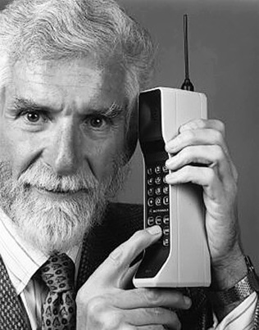 Martin Cooper with the first mobile phone
How a Call is Made

Mobile phones are, in a simple way, a two-way radio that has the same concept as a telephone. However, a mobile phone is much more complex than your regular walkie-talkie, this is because a mobile phone allows two people (sometimes more) to speak at the same time, it allows people to make calls and receive them, leaving voice mail as well as text messaging. Mobile phones follow the full-duplex system, which allows communication in both directions, and unlike half-duplex, this allows it to happen simultaneously.

When a phone call is placed, you dial a number and press the call button. When this happens, various steps follow up, these are:

Your mobile phone will search for the closest base station in order to have the strongest cell signal, and the best connection it can possibly have. In order to determine the strongest signal available, it will scan 21 different control channels. Your phone will then chose the strongest signal for it to use.

A message, which is about a quarter second (also known as an origination message) is sent out by the phone, this includes its Mobile Identification Number, the Electronic Serial Number and the number which has been dialled.

Once your mobile provider verifies that you are a customer, the base station sends a channel assignment message to the phone, which is another quarter of a second in length, telling the phone where the conversation will be. The mobile phone will then tune into the assigned channel and the call begins.

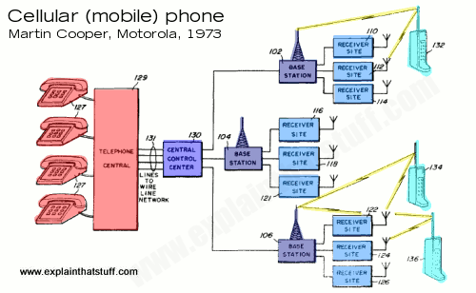

Protocols and Standard Bodies

The Global System for Mobile Communications, often shortened to GSM, is a standard developed by the ETSI (European Telecommunications Standards Institute). GSM describes the protocols for the second generation of cellular networks used by mobile phones.

Developed as a replacement for the first generation networks, the GSM standard originally described a digital, circuit switched network for full duplex voice telephony. This grew over periods of time to include data communications by packet data transport by EDGE. The standards are governed by the European Telecommunications Standards Institute.
The 3GPP (3rd Generation Partnership Project) is a partnership between groups of telecommunications associations, known as Organizational Partners. 3GPP initially was to make a globally applicable 3G mobile phone system based on the Global System for Mobile Communications specifications, but was later enlarged to include the development of GSM and 2G/2.5G standards (including EDGE), and UMTS 3G standards (including HSPA). The Universal Mobile Telecommunications is a standard developed by the 3GPP for third generation mobile networks based on the GSM standard.

3G refers to the third generation of advancements and developments in wireless technology, especially in mobile communications. As its name implies, the third generation follows the first generation and the second generation in wireless communications. While the third generation is considered relevant to mainly mobile wireless devices, it is also relevant to fixed wireless as well as portable wireless. In theory, a 3G system should be operational from any location, including homes, businesses, government offices, medical facilities, military and commercial aircraft (excluding restrictions when applicable) and portable devices.

Long Term Evolution Advanced is a standard for the fourth generation, which was standardized by the 3rd Generation Partnership Project.

Fourth generation wireless, or as it’s more commonly known as, 4G, includes the stage of broadband mobile communications which will surpass the third generation. However, while both standards bodies and carriers have not been able to definitively agree up what 4G will be, it is expected that end-to-end IP and high definition streaming video quality will be some of many of 4G’s features. The networks included with the fourth-generation are likely to use a combination of WiMAX and Wi-Fi.

Code-division multiple access is a type of multiplexing, which enables numerous signals to inhabit a single transmission channel, expanding the use of available bandwidth. Code-division multiple access uses analogue-to-digital conversion, this is used in ultra-high frequency cellular telephone systems.

Evolution data maximized is based on CDMA200 (which is a CDMA version of the IMT-2000 standard developed by the International Telecommunication Union), which supports mobile data communications at speeds ranging from 400 Kbps to 2Mbps.

Frequency division multiple access is the division of the frequency band allocated for wireless cellular telephone communication into 30 channels, each of these can carry a mobile phone conversation or carry digital data. This is a basic technology in the advanced mobile phone service, which is the most widely installed phone system (in North America). Each channel can be assigned to only one user at a time.

ComReg is the statutory body responsible of the electronic communications sector, this includes telecommunications, radio communications and broadcasting transmission. ComReg remit covers traditional telephone wire, television and radio, radio communications, mobile operators providing voice and data services and licensing. ComReg provides the layout for the introduction of new services such as 3G.

A 3G license allows the company it’s licensed to too provide a Third Generation Mobile service based upon a standard in the International Mobile Telecommunications. Existing 3G license holders include Vodafone Ireland, Three Ireland and Meteor Mobile.

ComReg also deal with other broadcasting licenses, the Digital Switchover is the process of replacing analogue television with digital. Digital transmissions offer more efficient use of radio spectrum, which provides benefits to the viewer, such as providing a larger number of TV programme services, higher quality pictures and sound and HD services.

Conclusions

In conclusion, one can see that making a mobile phone call is a lot more complex than just pressing the dial button and talking. Also showing us the standards and protocols that the European Telecommunications Standards Institute create and manage.

Bibliography

Know Your Mobile, (2015). The History of Mobile Phones From 1973 To 2008: The Handsets That Made It ALL Happen. [online] Available at: http://www.knowyourmobile.com/nokia/nokia-3310/19848/history-mobile-phones-1973-2008-handsets-made-it-all-happen [Accessed 7 Oct. 2015].

Streetdirectory.com, (2015). How is a Cell Phone Call Made?. [online] Available at: http://www.streetdirectory.com/travel_guide/133127/cell_phones/how_is_a_cell_phone_call_made.html [Accessed 10 Oct. 2015].

SearchMobileComputing, (2015). Mobile And Wireless Protocols [online] Available at: http://searchmobilecomputing.techtarget.com/tip/Mobile-and-wireless-protocols [Accessed 20 Oct. 2015].

3gpp.org, (2015). 3GPP. [online] Available at: http://www.3gpp.org/ [Accessed 23 Oct. 2015].

ETSI, (2015). ETSI - GSM. [online] Available at: http://www.etsi.org/technologies-clusters/technologies/mobile/gsm [Accessed 23 Oct. 2015].

http://www.webtrade.ie, W. (2015). Commission for Communications Regulation - ComReg. [online] Comreg.ie. Available at: https://www.comreg.ie/ [Accessed 29 Oct. 2015].

